# **Name: Abdurrahman Qureshi**

# **Roll No: 242466**

Assignment No: 1

**Topic: College Management System ER Diagram**

Steps to Create an ER Diagram:

Step 1: Identify Entities and Attributes

* Student: First name, Last name, MIS, Address, Birth date.
* Admission: Student_Num, Course_name, Date of enrollment.
* Lecturer: First name, Last name, Address.
* Timetable: Time, Date.
* Subjects: Attribute, Subject unit.

Defining attributes for each entity:

Student Entity:

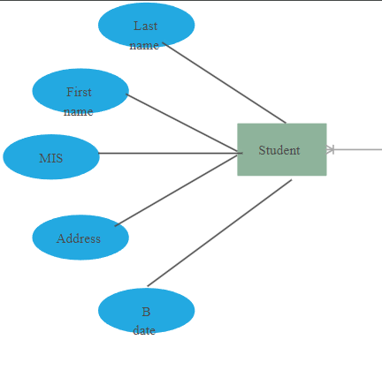

Admission Entity:

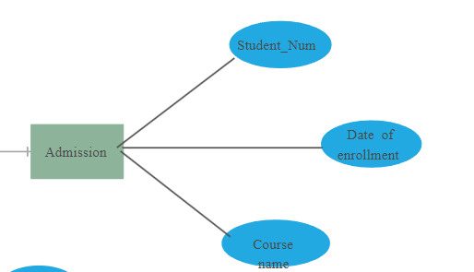

Time Table Entity:

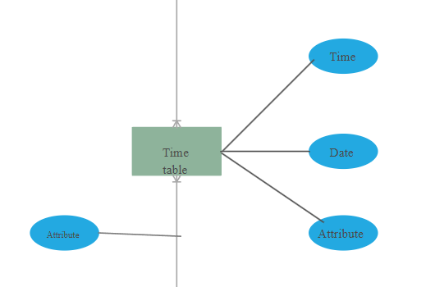

Subjects Entity:

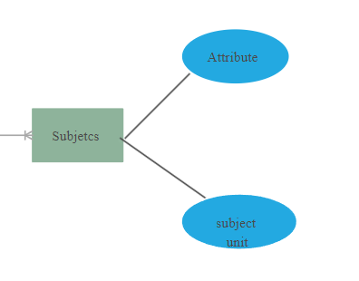

Subjects Entity:

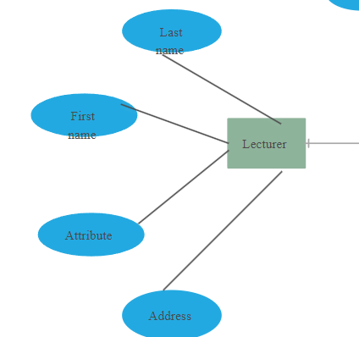

Step 2: Establishing Relationships

Identifying relationships between entities, such as:

* Student and Admission: Students take admission in courses.
* Lecturer and Lectures: Lecturers conduct various lectures.
* Lectures and Subjects: Lectures correspond to specific subjects.
* Admission and Timetable: After admission, a student's classes are scheduled on the timetable.

Establishing Relationships:

Take Admission:

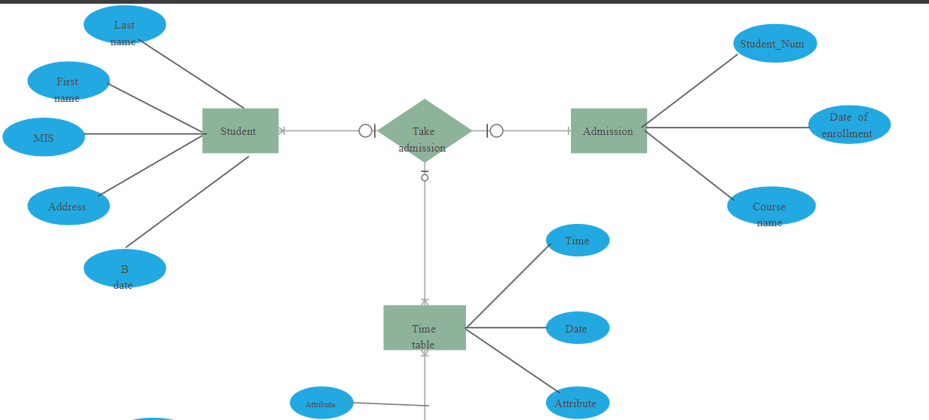

Lecture:

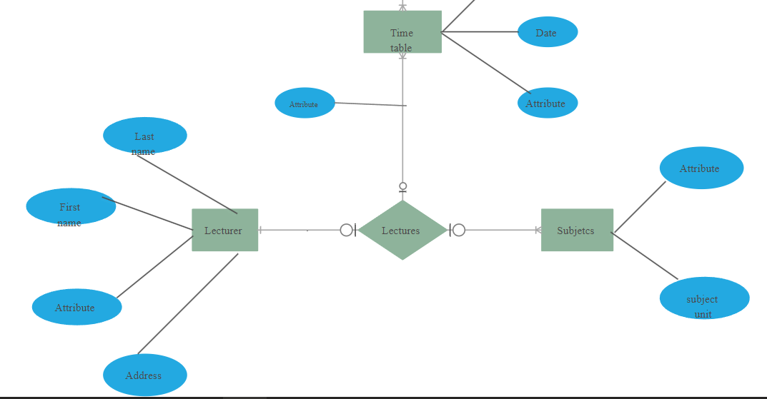

Step 3: Set Cardinality

Determining the cardinality of relationships:

* One student can enroll in many courses.
* One lecturer can conduct many lectures.
* One subject can be associated with many lectures.

Cardinality:

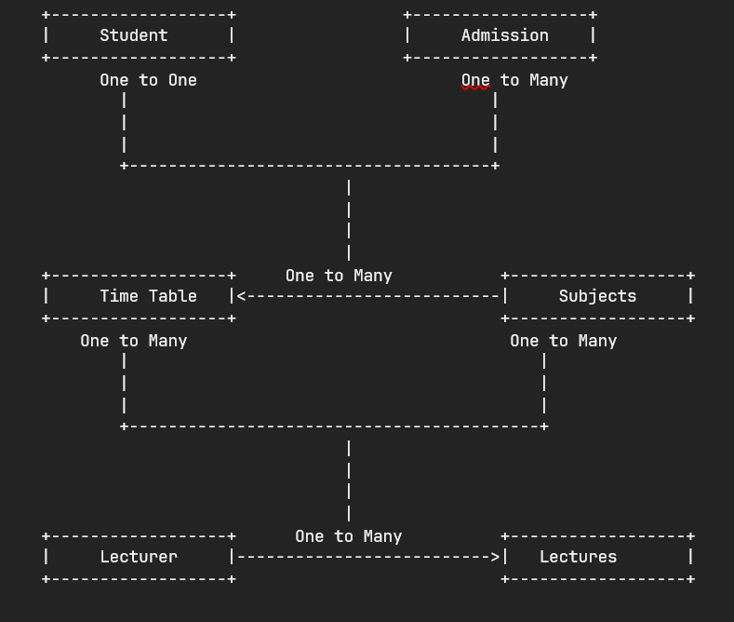

Step 4: Drawing the Diagram

* Use rectangles to represent entities.
* Use ovals for attributes.
* Use diamonds to represent relationships.
* Connecting entities with relationships using lines and indicate cardinality (1:1, 1, M).

Drawing the Diagram:

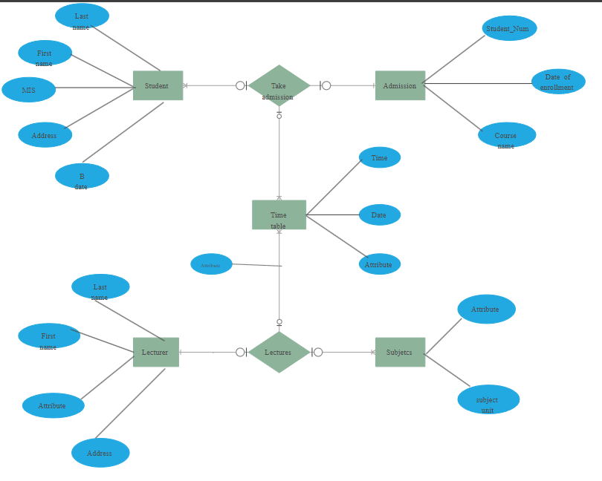

Step 5: Converting the ER Diagram into a table

**Students Entity:**   
- Name   
 - Address   
 - DOB   
 - Age   
 - Phone Number   
  
**Faculty Entity:**   
 - F_id   
 - F_name   
 - Salary   
 - F_mobile Number   
  
**Course Entity:**   
 - Id   
 - Course_name   
 - Duration   
  
**Department Entity:**   
 - Dept_id   
 - Dept_name   
  
**Hostel Entity:**   
- Hostel_id   
 - Hostel Name   
 - No_of_seats   
  
**Subjects Entity:**   
 - Subject_no   
 Subject_name   
  
**Exams Entity:**   
 - Exam Code   
 - Room   
 - Date